**Course Linux Requirements**

1. There are hundreds of distributions. we have decided to focus on the three major distribution families.
2. The below are the distributions from within each family.
3. The families and representative distributions we are using are:

* Red Hat Family Systems (including CentOS and Fedora)
* SUSE Family Systems (including openSUSE)
* Debian Family Systems (including Ubuntu and Linux Mint).

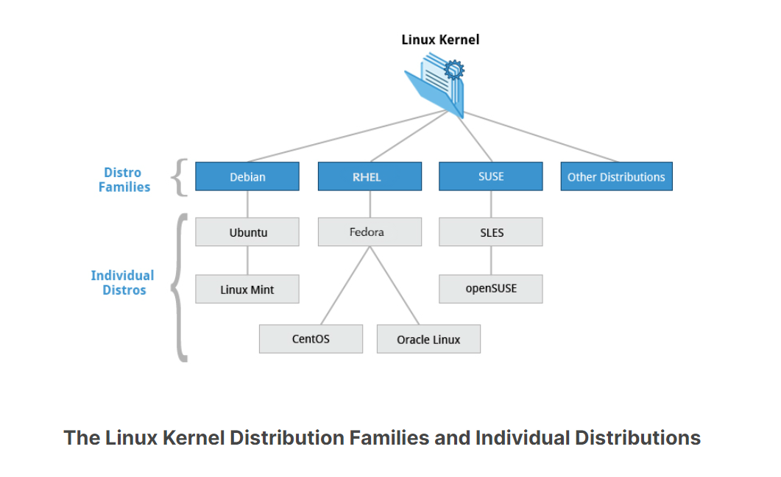

**The Red Hat Family:**

1. Red Hat Enterprise Linux (RHEL) heads the family that includes CentOS, CentOS Stream, Fedora and Oracle Linux.
2. Fedora has a close relationship with RHEL and contains significantly more software than Red Hat's enterprise version.
3. Fedora is used as a testing platform for future RHEL releases.
4. We will use CentOS Stream and CentOS more often for activities, demonstrations, and labs because there is no cost to the end user, and there is a longer release cycle than for Fedora (which releases a new version every six months or so).
5. The basic version of CentOS is also virtually identical to RHEL.
6. However, CentOS 8 has no scheduled updates after 2021. The replacement of CentOS 8 is CentOS 8 Stream
7. The difference between the CentOS and CentOS Stream versions is CentOS Stream gets updates before RHEL, while CentOS gets the updates after RHEL

**Key Facts About the Red Hat Family:**

1. Fedora serves as an upstream testing platform for RHEL.
2. CentOS is a close clone of RHEL, while Oracle Linux is mostly a copy of RHEL with some changes.
3. A heavily patched version 3.10 kernel is used in RHEL/CentOS 7, while version 4.18 is used in RHEL/CentOS 8.
4. It supports hardware platforms such as Intel x86, Arm, Itanium, PowerPC, and IBM Systems.
5. It uses the yum and dnf RPM-based yum package managers (covered in detail later) to install, update, and remove packages in the system.
6. RHEL is widely used by enterprises which host their own systems.

**The SUSE Family:**

1. The relationship between SUSE(SUSE Linux Enterprise Server, or SLES) and openSUSE is similar to the one described between RHEL, CentOS, and Fedora.
2. We use openSUSE as the reference distribution for the SUSE family, as it is available to end users at no cost
3. since SLES and openSUSE are extremely similar, the material that covers openSUSE can typically be applied to SLES with few problems.

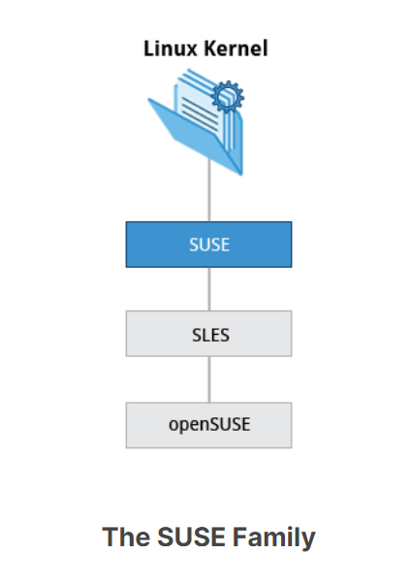

**Key Facts About the SUSE Family:**

1. SUSE Linux Enterprise Server (SLES) is upstream for openSUSE.
2. Kernel version 4.12 is used in openSUSE Leap 15.
3. It uses the RPM-based zypper package manager (we cover it in detail later) to install, update, and remove packages in the system.
4. It includes the YaST (Yet Another Setup Tool) application for system administration purposes.
5. SLES is widely used in retail and many other sectors.

**The Debian Family:**

1. The Debian distribution is upstream for several other distributions, including Ubuntu
2. In turn, Ubuntu is upstream for Linux Mint and a number of other distributions.
3. Debian is commonly used on both servers and desktop computers.
4. Debian is a pure open source community project (not owned by any corporation) and has a strong focus on stability.
5. Debian provides by far the largest and most complete software repository to its users of any Linux distribution.
6. Ubuntu aims at providing a good compromise between long term stability and ease of use.
7. Since Ubuntu gets most of its packages from Debian’s stable branch, it also has access to a very large software repository.

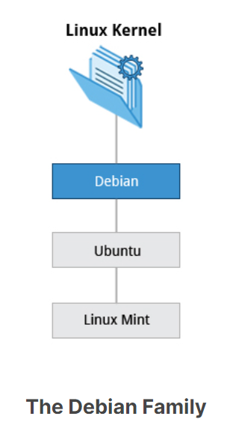

**Key Facts About the Debian Family:**

1. The Debian family is upstream for Ubuntu, and Ubuntu is upstream for Linux Mint and others.
2. Kernel version 5.8 is used in Ubuntu 20.04 LTS(Long Term Support).
3. Debian uses the DPKG-based APT package manager (using apt, apt-get, apt-cache, etc., which we cover in detail later) to install, update, and remove packages in the system.
4. Ubuntu has been widely used for cloud deployments.
5. While Ubuntu is built on top of Debian and is GNOME-based under the hood, it differs visually from the interface on standard Debian, as well as other distributions.